INSY 4305 Lab 5 Instructions

**Please download, run, and understand Lab_5_Starter program before you start this lab**

1. Examine the class CellPhone with the following fields: (*CellPhone.java* )

* String model, manufacturer, double retailPrice
* Add Constructors, Accessors and Mutators.
* Override toString() method

1. Create appropriate CellPhone Class Exceptions for the following error conditions: (Chapter 11)

* An empty string is given for the cellphone’s model. *InvalidModelException.java*
* An empty string is given for the cellphone’s manufacturer. *InvalidManufacturerException.java*
* An invalid number is given for the cellphone’s retail Price. This would be a negative number or a number greater than 1500. *InvalidRetailPriceException.java*

1. Modify the CellPhone class so that it throws the appropriate exception when any of these errors occurs. (Chapter 11)
2. Incorporate CellPhone's user-defined Exception classes from step 2 in CellPhoneInventory.java (line # 60…) using try catch blocks (Chapter 11)

Open CreateLoginForm.java to run the program using hard-coded username/password (*in step 5 you will read the authentication from a text file*)

Username: start

Password: lab5

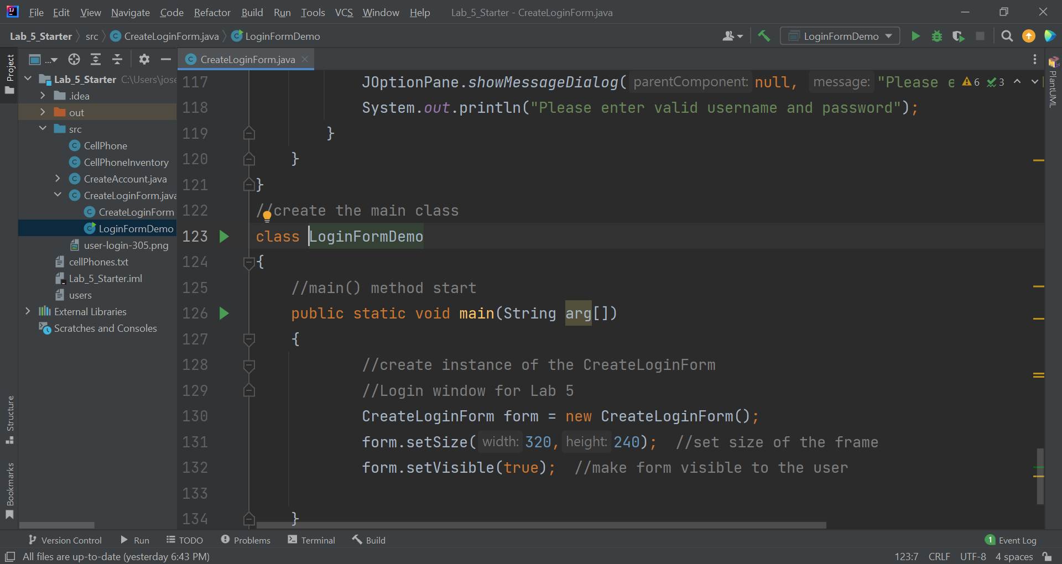

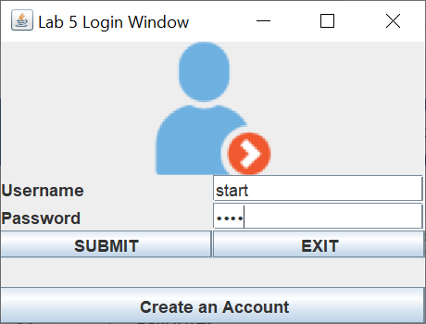

Click on **SUBMIT** button

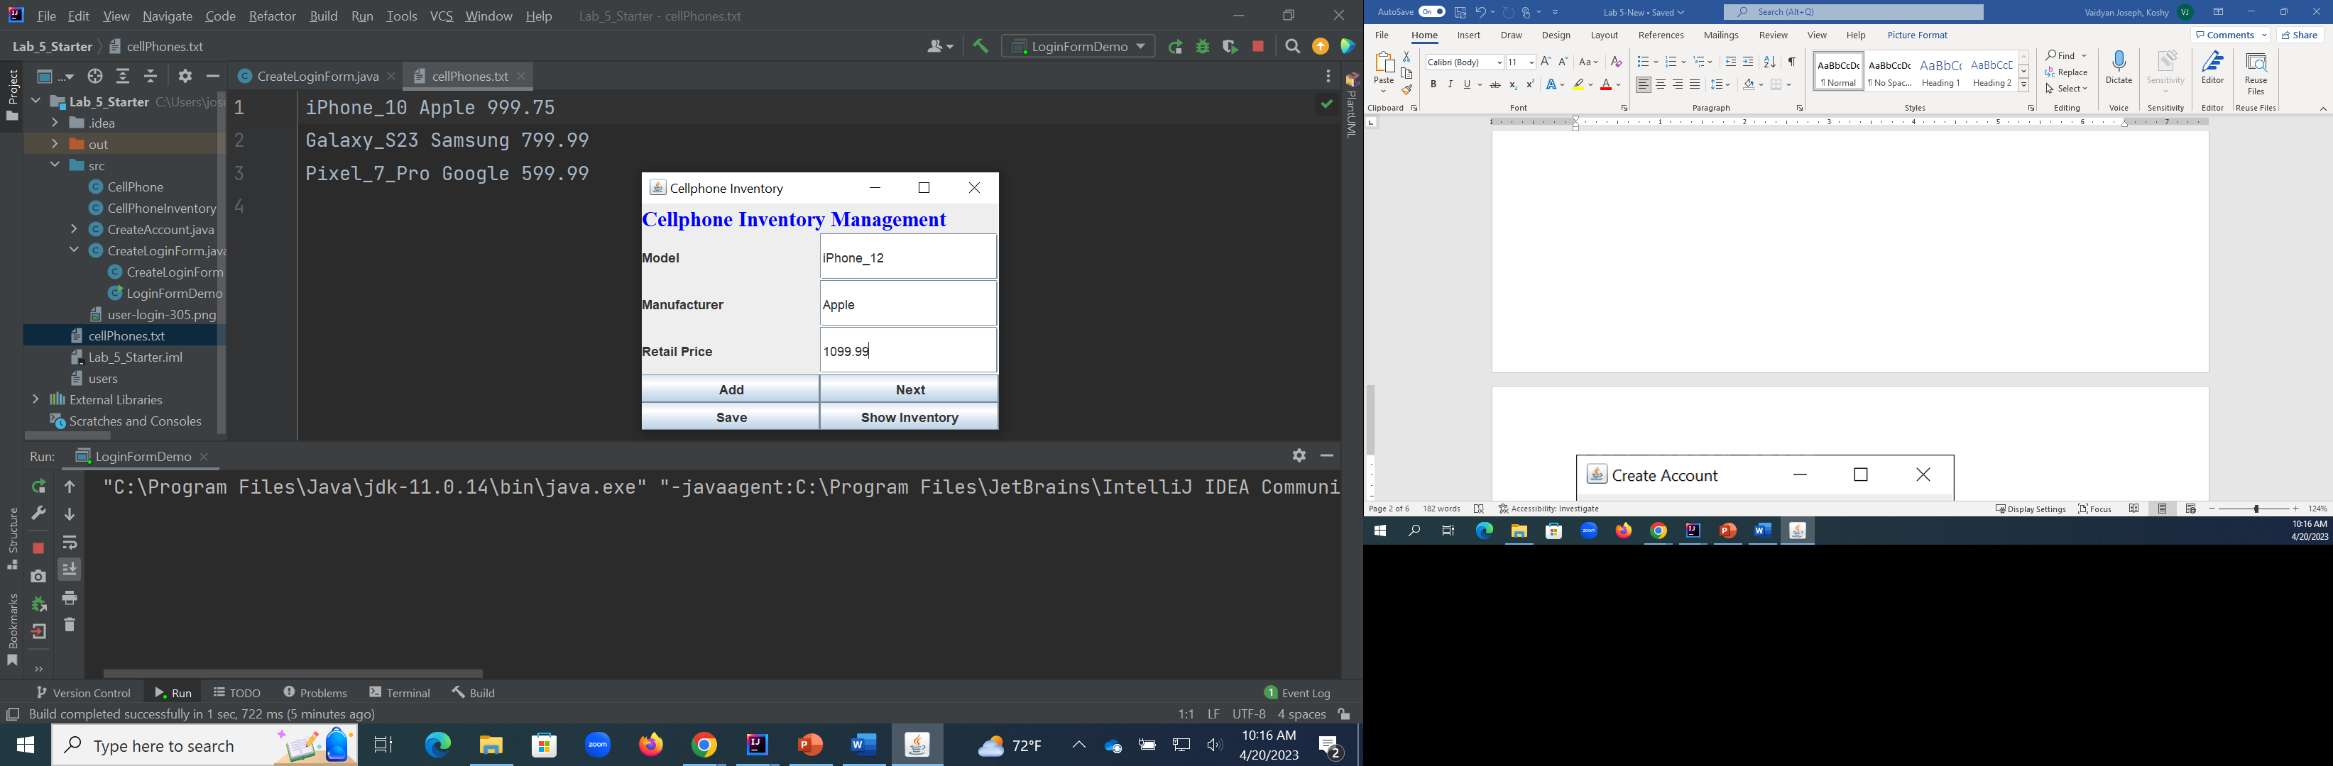

Click on **Add** button, you can see Dialog window appears like this.

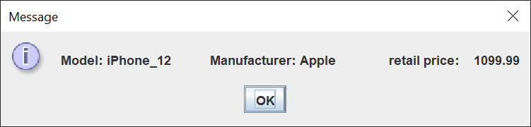

Click OK

Click on **Next** button

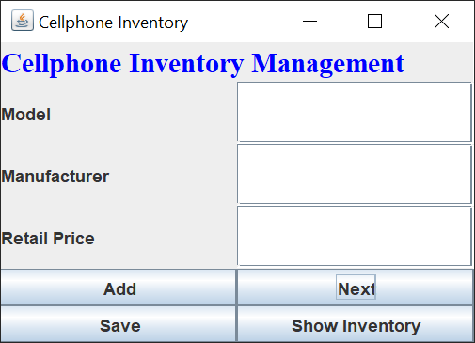

Try to add one cellphone (leave the Model text field empty)

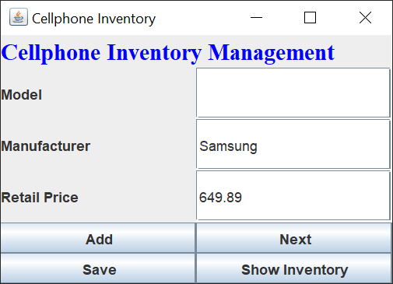

Click on **Add** button

Dialog window appears with model info missing

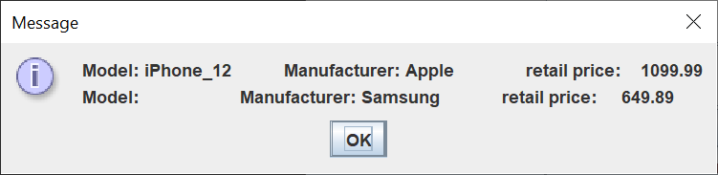

Click OK

Try to add one cellphone (leave the Retail Proce text field empty)

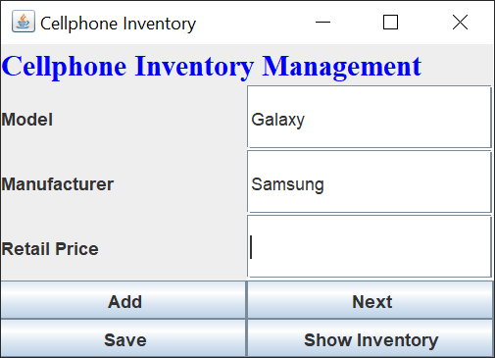

Click on Add button

Now the error message appears as shown below.

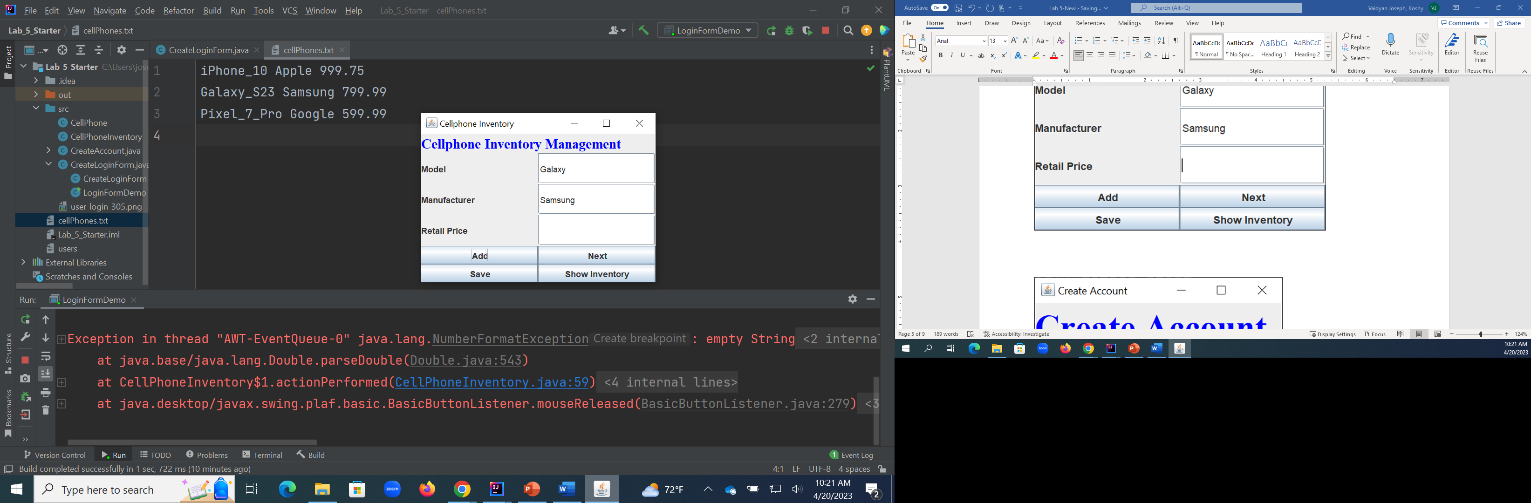

After you incorporate CellPhone's user-defined Exception classes (step 2) in CellPhoneInventory.java (line # 60…) using try catch blocks, the program should display appropriate Dialog windows and manage valid data entry.

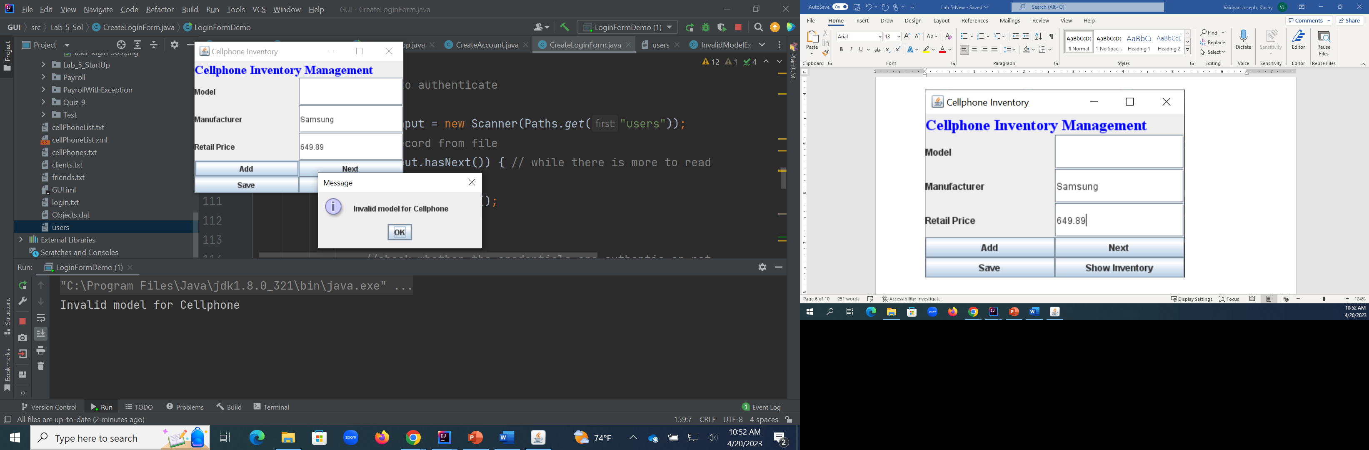

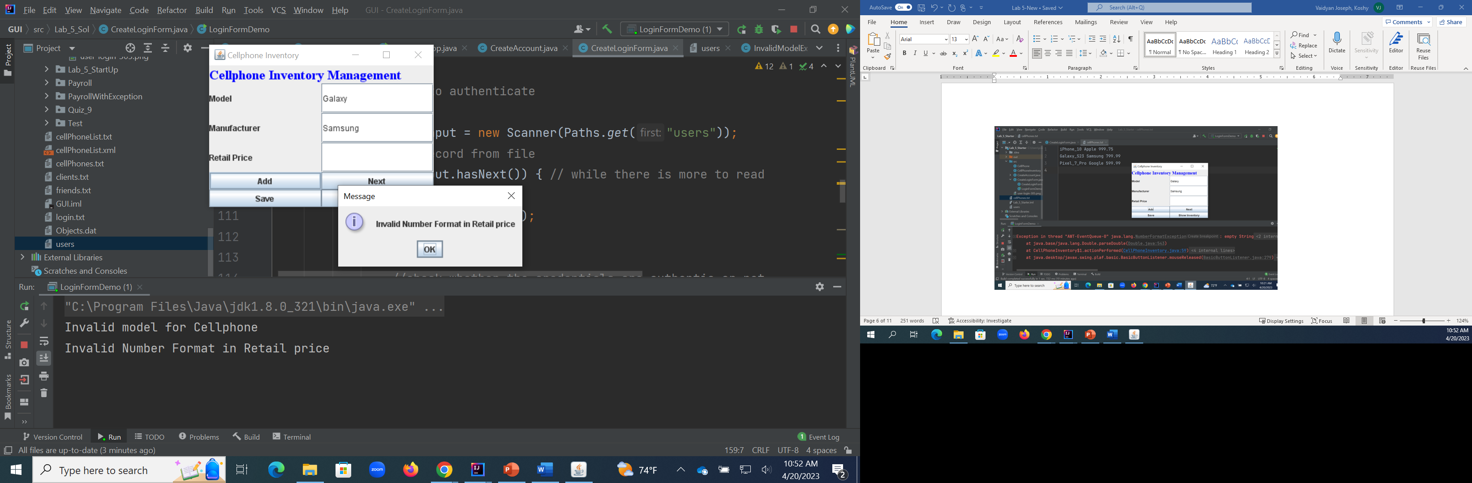

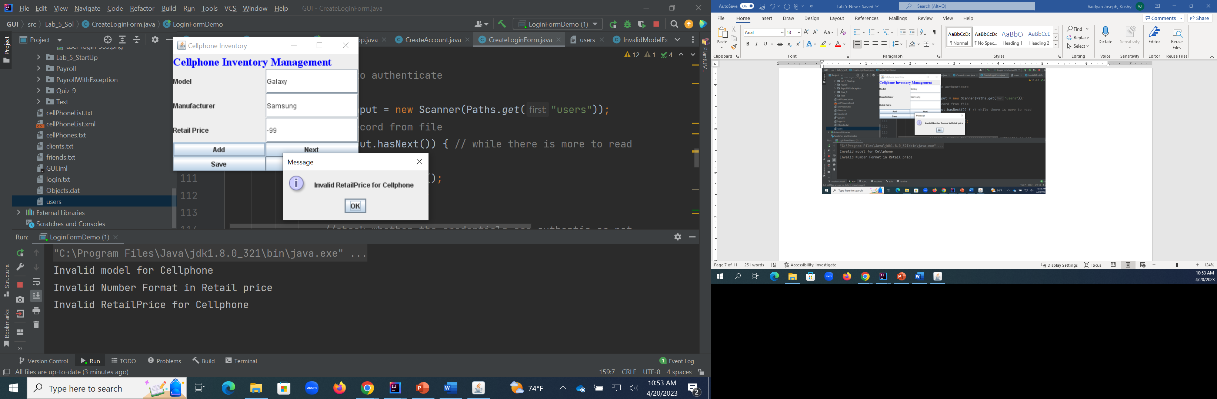

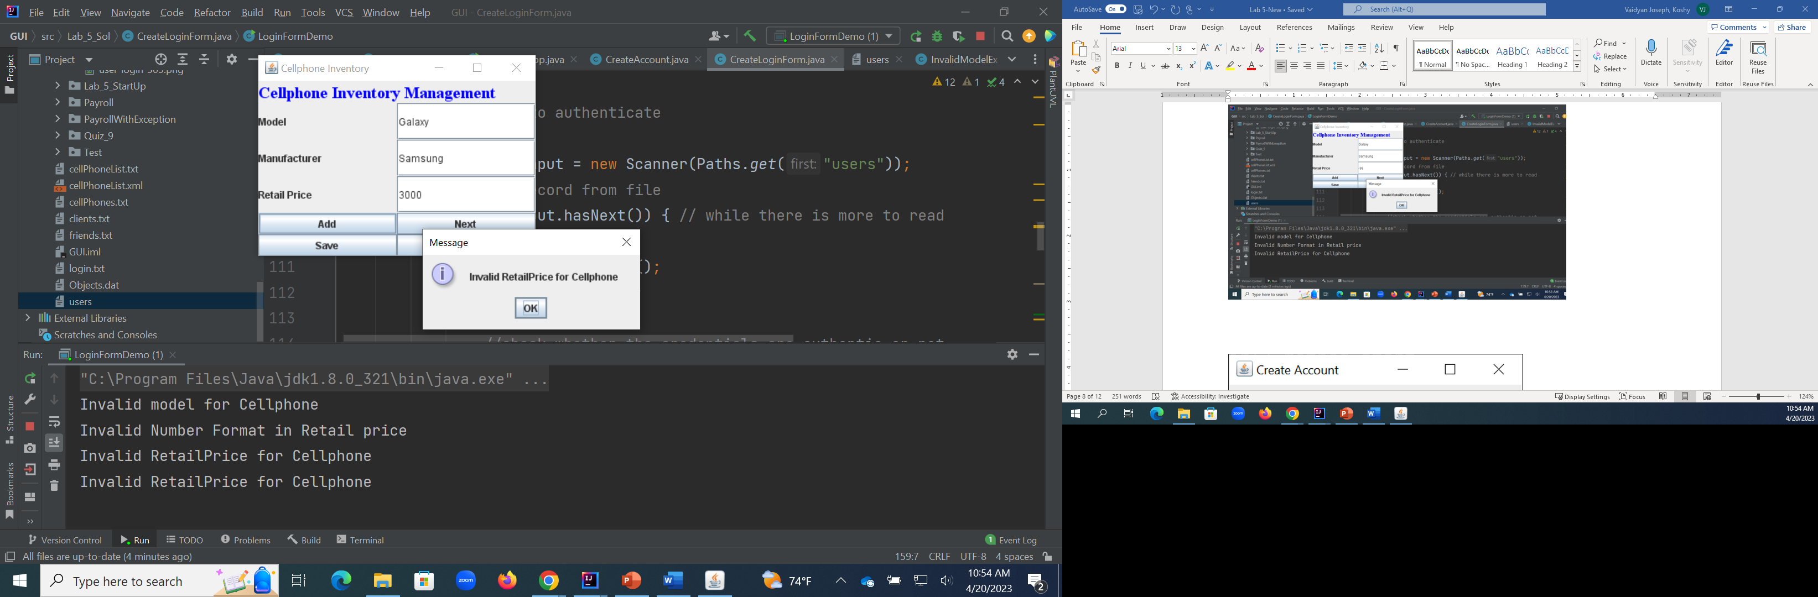

1. Reading username and password from text file to authenticate login window. Please incorporate your file reading codes in line 98 of **CreateLoginForm.java**) **(Chapter 15)**

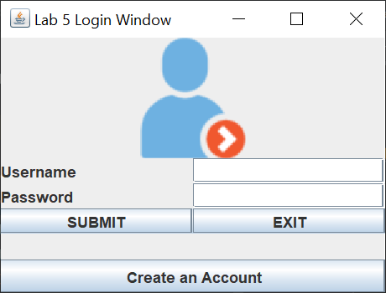

Click on **Create an Account** button

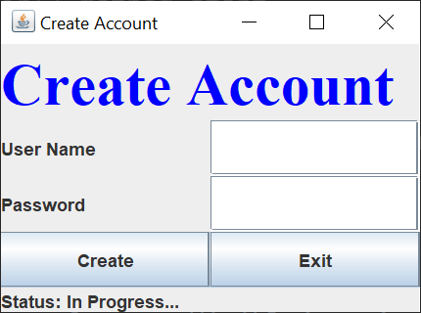

Enter your choice of username and password to create users.txt file.

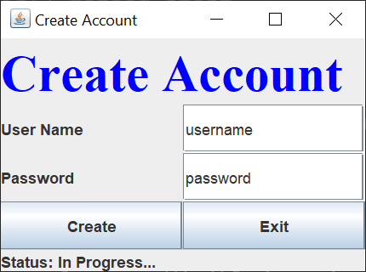

Click on **Create** button

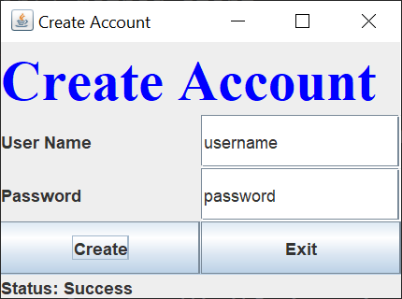

Check the users file to see the data entered from **Create Account** window

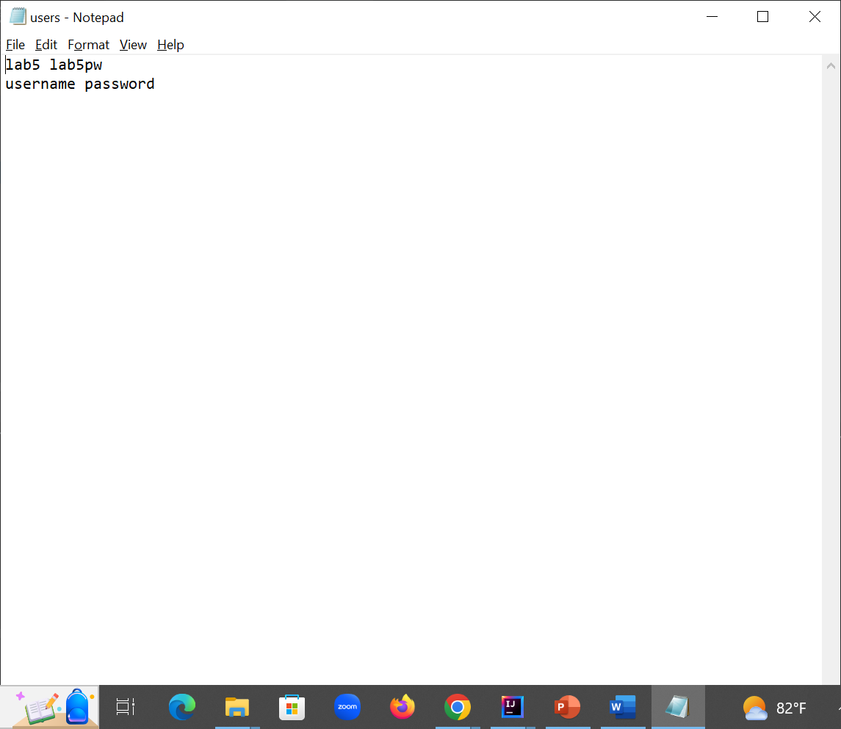

Now you should be able to login with the username/password stored in users.txt file instead of using hardcoded “start/lab5” values for username/password.

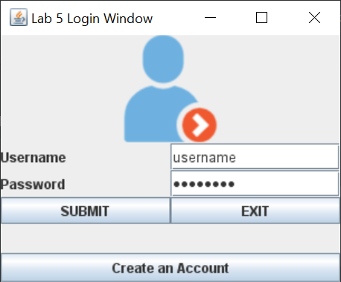

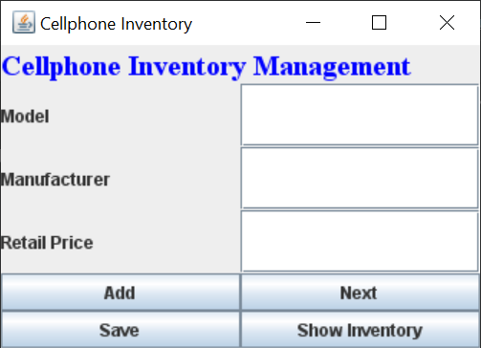

*Lab 5 To Do List:*

* Add InvalidModelException.java (5%)
* Add InvalidManufacturerException.java (5%)
* Add InvalidRetailPriceException.java (5%)
* Modify CellPhone.java (15%)
* Add Exception handling in CellPhoneInventory.java (line # 60…) (20%)
* Add file handling code to read username/password from users.text in CreateLoginForm.java (line # 98…) (20%)
* Output screenshot(s)(30%)

Note: Sparingly comment your java source code, save all the files and output screenshot(s) in ***your_lastname_lab_5*** folder, zip it, and upload for grading.

Thank you!